# JS Advanced: Regular Exam - 07.07.19

Exam problems for the ["JavaScript Advanced" course @ SoftUni](https://softuni.bg/courses/js-advanced). Submit your solutions in the SoftUni Judge system at <https://judge.softuni.bg/Contests/Compete/Index/1715#0>.

# Problem 1. SoftDo (DOM Manipulation)

### Use the given skeleton to solve this problem.

### Note: You have NO permission to change directly the given HTML *(index.html file)*.

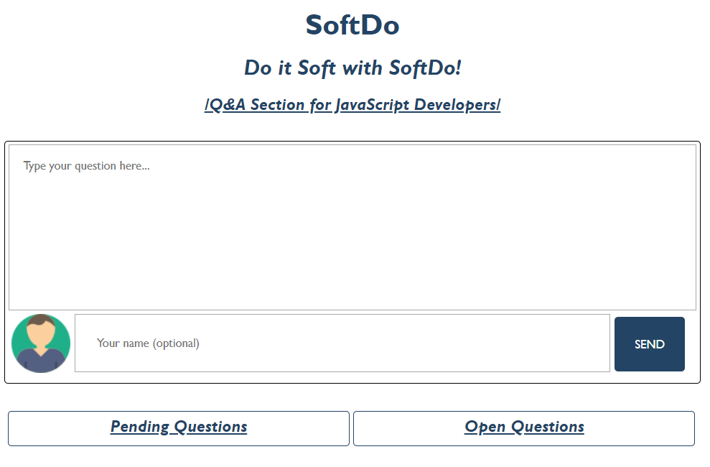

### Your Task

Write the missing JavaScript code to make the SoftDo application work as expected.

#### [Ask Question]

When the textarea *(Type your question here…)* is filled with some question and the button [**SEND**] is clicked, the current question should be displayed in the [**Pending** **Questions**] **section.** The input field for the username is **NOT required** - if it is filled, show the **given** **username** under the question, otherwise, the username is **Anonymous**.

##### [Ask Question as an Anonymous User *(input field is empty)]*

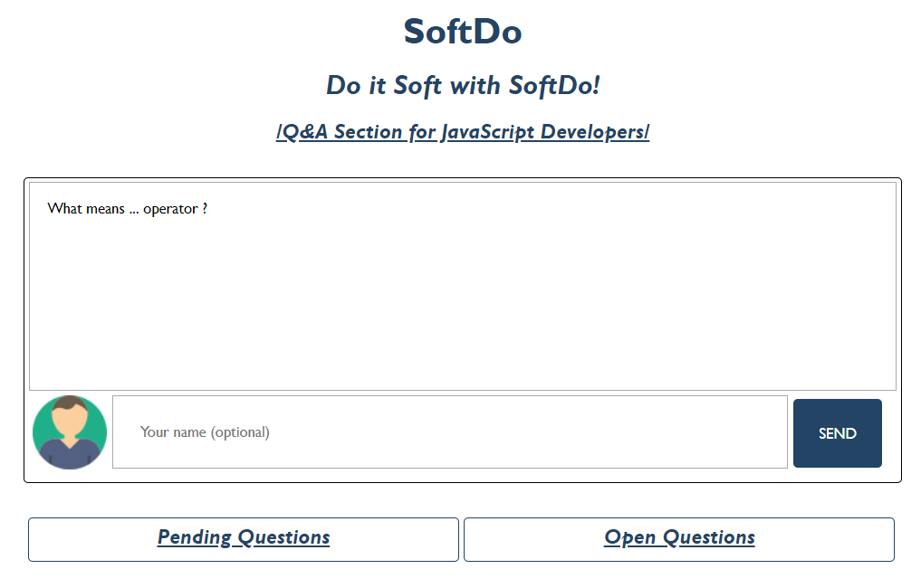

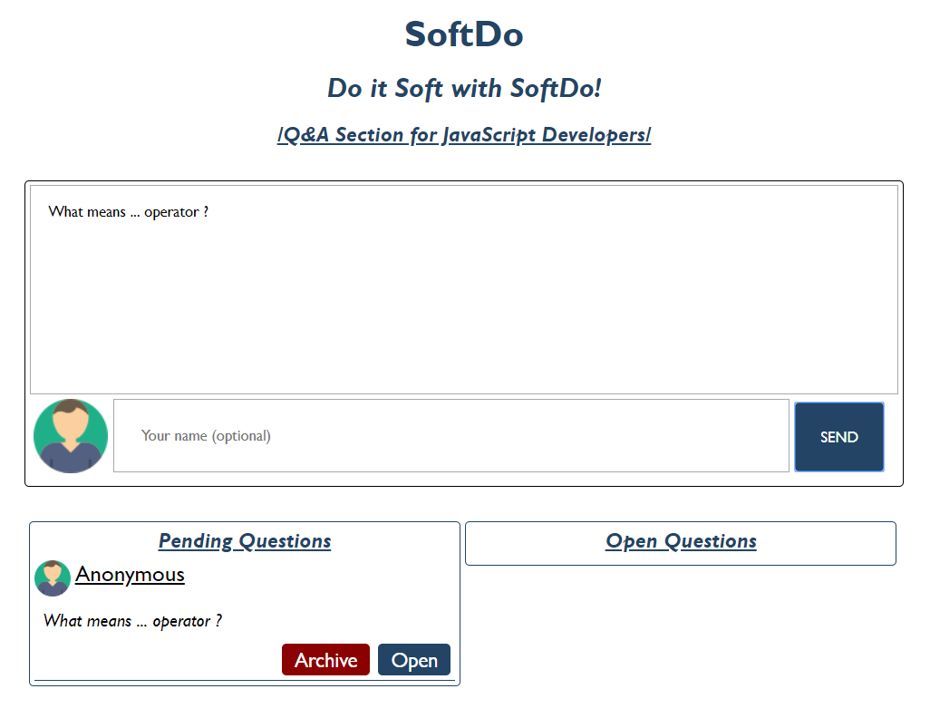

##### [Ask Question with Username *(input field is filled with some username)]*

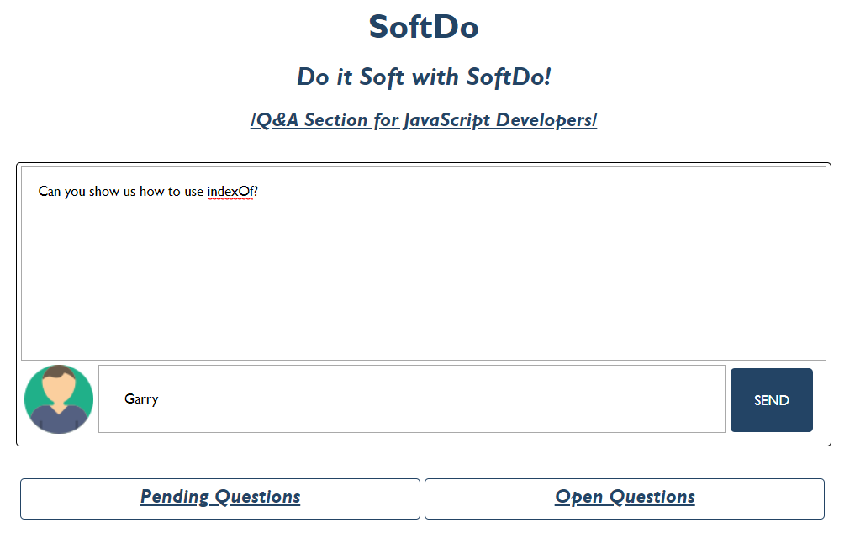

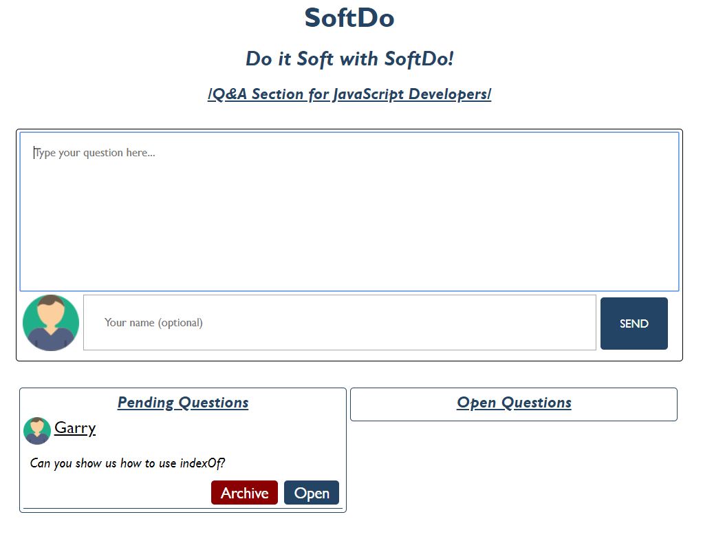

##### [Pending Question]

**Each** pending question:

* Children elements must be wrapped in a divelement with class "pendingQuestion"
  + First child is img which is same for every user (Anonymous or not). The user icon is provided in the skeleton resources (**images** **folder**). Each **img** should have **src**, **width** and **height** **attributes**.
  + Second child is a spanelementwhich holds the **username** (the given one from the input field or the Anonymous one).
  + Third child is а p **element**, which is the given question from the textarea.
  + The last (fourth child) is a divelementwith **class** "actions" which is а parent element of the two buttons ([Archive] and [Open])
    - [**Archive**] button has class "archive" and text content "Archive"
    - [**Open**] button has **class** "open"and text content "Open"
* Should be appended to the divwith id "pendingQuestions"

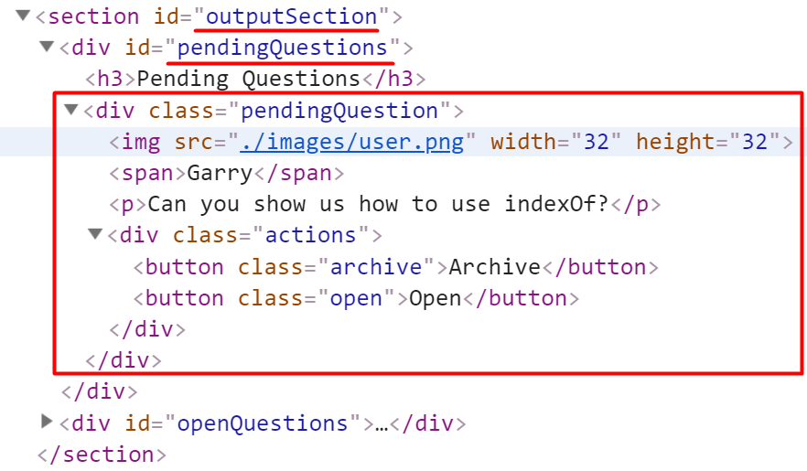

Clicking on the [**Archive**] **button** should **remove** the current question (divelement).

#### [Open Question]

If the [**Open**] **button** is clicked, the current question should be **moved (Append)** from the "pendingQuestions" section to the "openQuestions" section.

##### [Open a Question *(Moved from the [Pending] to the [Open] section)]*



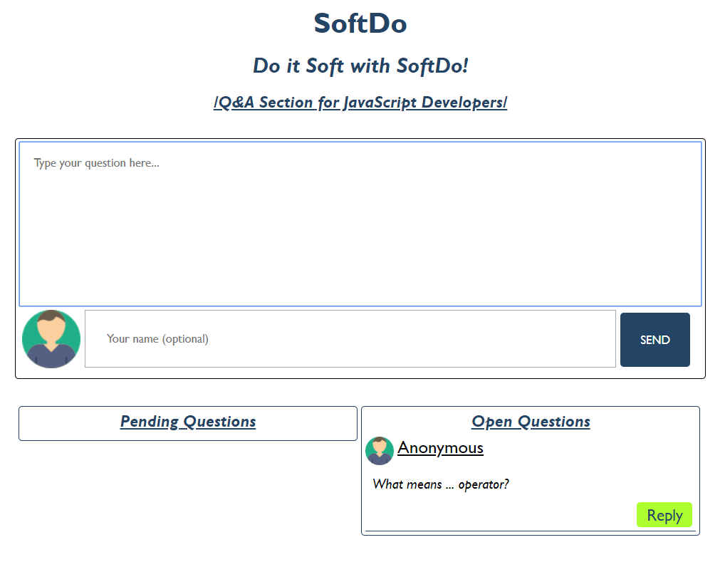

##### [Open Question Structure]

**Each** open question:

* Children elements must be wrapped in a **div element** with class "**openQuestion**"
  + First child is **img** which is same for every user (Anonymous or not). The user icon is provided in the skeleton resources (**images** **folder**). Each **img** should have **src**, **width** and **height** **attribute**
  + Second child is a **span element** which holds the **username** (the given one from the input field or the Anonymous one)
  + Third child is a **p element**, which is the given question from the **textarea**
  + Fourth child is a **div element** with **class** "**actions**" which is a parent element of the [**Reply**] **button**
    - [**Reply**] **button** has **class** "**reply"** and text content "**Reply**"
  + The last child here is a **div** **element** with class "**replySection**" which is a parent element of the **input**, **button** and **ol** elements:
    - **Input** **element** should have **class** "**replyInput**", **type** "**text**" and **placeholder** "**Reply to this question here...**" Set in that order!
    - **Button** element should have **class** "**replyButton**" and text content "**Send**"
    - Theorderedlist **(ol element)** should **two** attributes (**class** "**reply**" and **type** "**1**") Set in that order!
* Should be appended to the **div** with id "**openQuestions**"

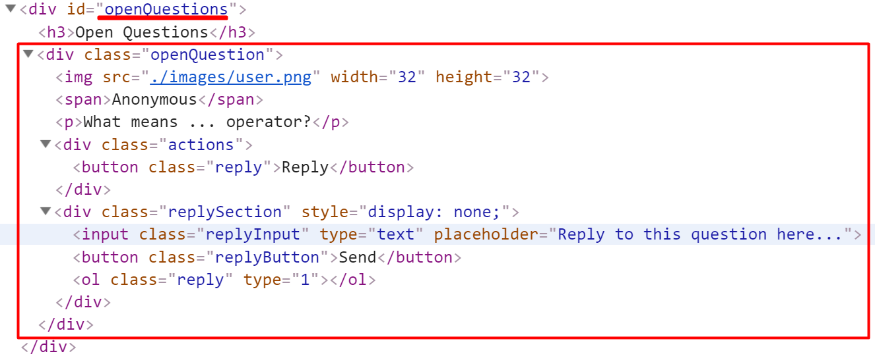

**Keep in mind** when the pending question is moved (appended) to the open questions section, the current question structure should be like the example above (The elements must be created inside the **replySection** but the section should **not be displayed**)

#### [Reply to the question]

By default, every **div element** with class "**replySection**" has **CSS** **styles** which are **property** **display**-**value** **none** (**display: none**), but if some of the [**Reply**] **buttons** are clicked, the current **replySection** must be shown (The **display** **property** must be **changed** to **block** (**display: block**). If the button [**Back**] is clicked again (when the section is displayed), the styles must be changed again to **display:none.**

If the **input** **field** in the "**replySection"** is filled with some text (answer to the current question) and the [**Send**] button is clicked, the current answer (the input value) must be appended to the ordered list (**ol element**) like text content on list item (**li element**)

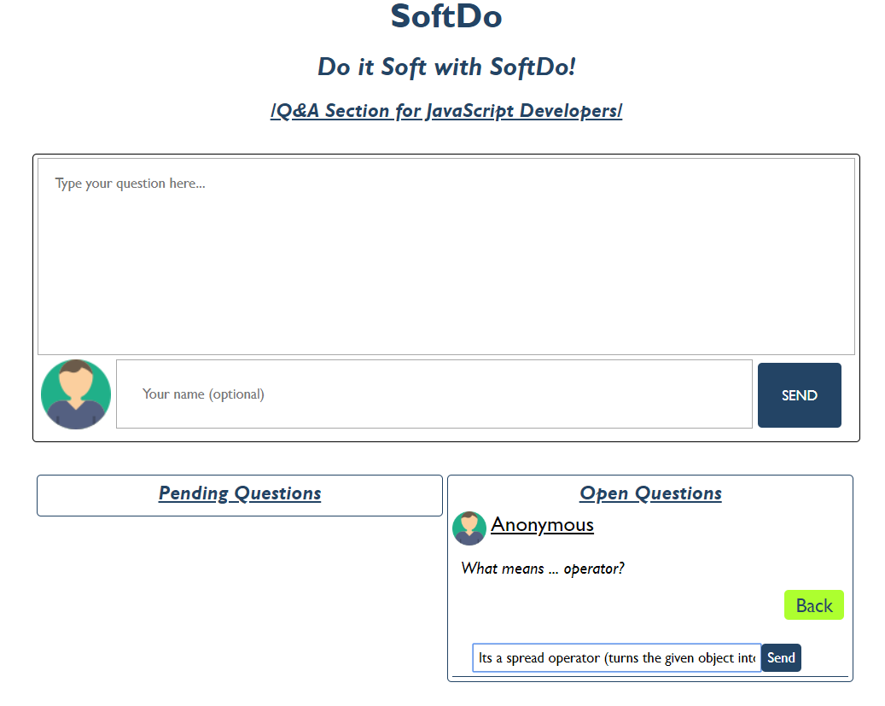

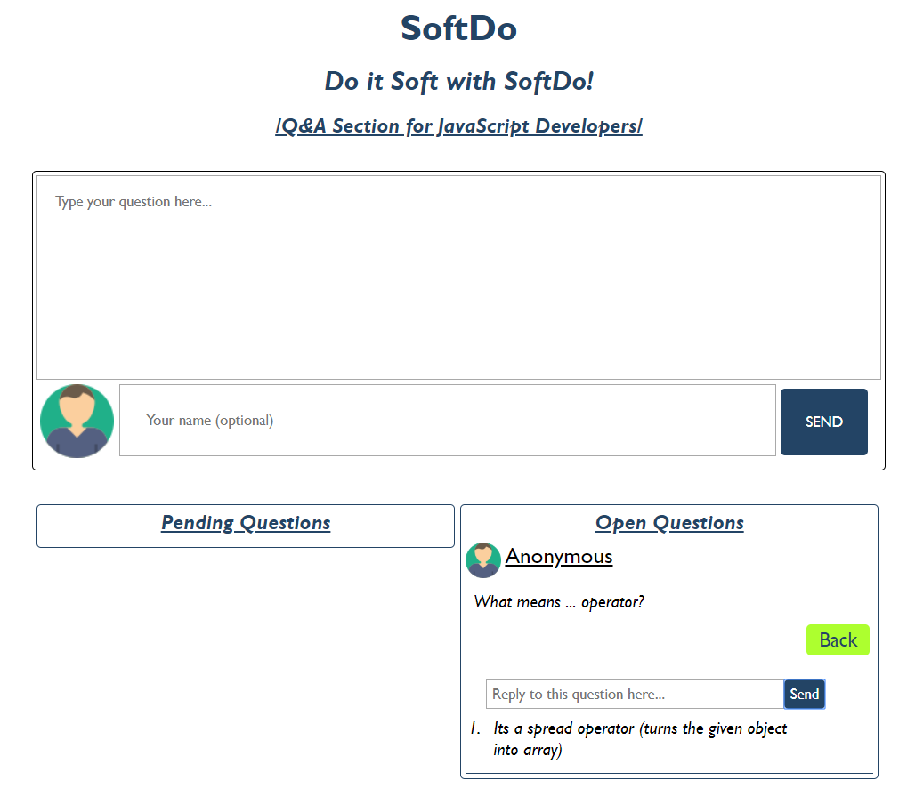

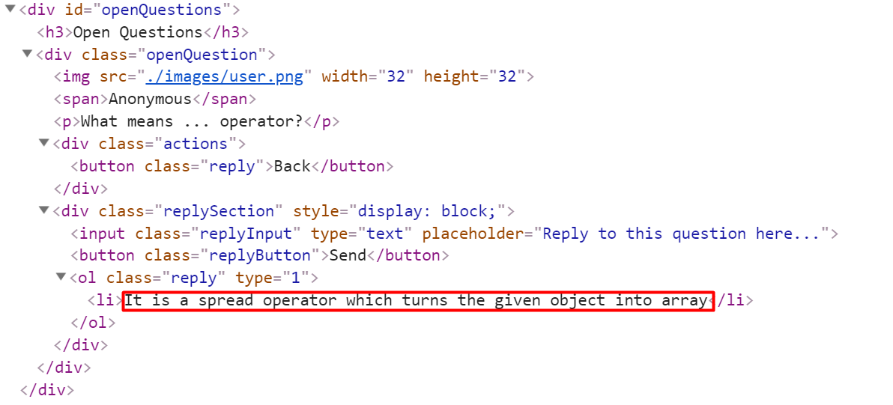

**Problem 2. PizzUni**

Use the provided **PizzUni** **class** to solve this problem.

**Your Task**

Using **Mocha** and **Chai** write **unit** **tests** to test the entire functionality of the **PizzUni class**. Make sure instances of it have all the **required** **functionality** and **validation**. You may use the following code as a template:

describe(**"*Tests* …"**, **function**() {

describe(**"*TODO* …"**, **function**() {  
 ***it***(**"*TODO …*"**, **function**() {

*//* ***TODO:*** …

});

});  
 *//* ***TODO:*** …

});

**Functionality**

The code inside the **pizzuniClass.js** file defines a class that contains information about an auto service. An instance of the class should support the following operations:

**constructor()**

An instance of **PizzUni class** should have the following **3** **properties**:

* **registeredUsers** - by default is an **empty** **array**
* **availableProducts** - by default isan **object** thatmust have only 2 properties:
  + **pizzas** - array with **3 strings:**("Italian Style", "Barbeque Classic" and "Classic Margherita")
  + **drinks** - array with **3 strings** ("Coca-Cola", "Fanta" and "Water")
* **orders** -by default is an **empty** **array**

**registerUser({email})**

This function **registers** a user by the given email (**string**) into **registeredUsers** **property**

* Receives a **string** (email)
* If the email is **already used** for registration before that, the expected behavior of the class is to **throw an error** with the following message:   
  `**This email address (${email}) is already being used!**`
* Otherwise, the given email is successfully registered to the **registeredUsers** **property** as an object. That object holds the given **email** and **orderHistory** which by default is an **empty** **array.**
* At the end, the **current** **object** should be **returned**.

**makeAnOrder()**

This function **makes** **an** **order** from an **already** **registered** user and **saves** the **current** **order** into their **orderHistory** property.

* Receives 3 parameters - **email**, **orderedPizza** and **orderedDrink**
  + If the incoming email is **NOT** registered in the **registeredUsers** **property**, the following error should be thrown:  
    "**You must be registered to make orders!**";
* An order is considered **valid** when the incoming **orderedPizza** is one of the **pizzas** in the **availableProducts** **property**. If it is not the following error is thrown:  
  "**You must order at least 1 Pizza to finish the order.**".
* The **orderedDrink** is **not required.** But if it is ordered, the drink should be one of the **drinks** in the **availableProducts** **property**.
* When the **order is valid** a new **object** which holds information about the current order (**the ordered pizza** and **the ordered drink, if any**) is pushed in the registered user **orderHistory** **property.** Also, a new **object** which holds information like (**ordered** **pizza**, **ordered** **drink** (if any), **email** and **status** which is **pending**) is pushed in the **orders** property.
* The following function **returns** a **number** (the **index** of the order in the **orders** array)

**completeOrder()**

This function **changes** the **status** of the **first** **object** with status "**pending**" to "**completed'** in the **orders** property and **returns** the **current** **object**.

**detailsAboutMyOrder({id})**

* Receives a **number** (id) which is the **index** for the current order
* If the current **order id** (index) is valid, the function returns the status of that order in format:  
  "**Status of your order: {pending/completed}**"

**doesTheUserExist({email})**

* Receives a **string** (email) and **returns** an **object** with all the registered users with that email

**Submission**

Submit your tests inside a **describe()** statement, as shown above.

# Problem 3. Computer

**class** Computer {  
 *//* ***TODO: implement this class...***  
}

### Your Task

### Write a Computer class which supports the described functionality below.

### Functionality

#### constructor()

Receives **3** parameters at initialization of the class (**ramMemory, cpuGHz, hddMemory**), where each of them is a **number.**

Should have these **5** properties:

* **ramMemory** - **number** (should be the same as the received **ramMemory**)
* **cpuGHz** - **number** (should be the same as the received **cpuGHz**)
* **hddMemory** - **number** (should be the same as the received **hddMemory**)
* **taskManager** – **empty** **array**
* **installedPrograms** - **empty** **array**

#### installAProgram({name}, {requiredSpace})

This **function** should **install a new program** on the computer and **save** it in the **installedPrograms** **property**.

* If the **total** **hddMemory** is **exceeded** while trying to install a new program, **new error** should be **thrown** with the following message:  
  "**There is not enough space on the hard drive**"
* If there is available space to install the given program, a **new object** with the given **name** and **requiredSpace** should be created and stored to the **installedPrograms** **array** **property.**

Keep in mind that when you successfully install a program you must **decrease** the total **hdd** **memory** on the computer with the **capacity** for the **currently installed** **program**!

The following function should **return** the **newly** **created** **object**.

#### uninstallAProgram({name})

This **function** should **uninstall** an **already** **installed** program on the computer (**remove** the **first** **program** with the **given** **name** from the **installedPrograms** **property**).

* If there **are no installed** programs with the **given name,** a **new error** should be **thrown** with the following message:  
  "**Control panel is not responding**"
* If **installedPrograms** **property** contains an object with the **given** **name**, that object should be **removed** from the array.

Also logically reversed move is to **increase** the total **hdd** **memory** with the **capacity** of the **currently** **uninstalled** **program**!

This function should **return** the **installedPrograms** **array** where the given program name is excluded.

#### openAProgram({name})

This **function** should **open** an already installed program on the computer.

Receives a **string** (name of that program)

* If the given **name** is **not** present in the **installedPrograms property**,a **new error** should be **thrown** with the following message:  
  "**The ${name} is not recognized**"
* If the given name is an installed program and it is already open, a new error should be thrown with the following message:  
  **The ${name} is already open**"

To open an installed program, you must **calculate** how much **RAM** **memory** and **CPU** **usage** the program will need.

To find out how much:

* **ram memory** the current program will need, use the following formula:  
  **(programRequiredSpace / totalRamMemory) * 1.5**
* **cpu** **usage** the current program will need, use the following formula:  
  **( ( programRequiredSpace / CPU GHz ) / 500) * 1.5**

Keep in mind the both formulas calculate a numbers in **percent** (%) for the current ram and cpu usage.

If the **total** **ram** **usage reaches or exceeds 100%** (the ram usage for all opened programs), the function should throw a **new error** with the following message:  
**"{programName} caused out of memory exception**"

If the **total cpu usage reaches or exceeds 100%** (the cpu usage for all opened programs), the function should throw a **new error** with the following message:  
"**{programName} caused out of cpu exception**"

If both (**ram usage and cpu usage**) **reaches** or **exceeds** **100**% return the ram memory exception case.

When **ram** and **cpu** **usages** is **calculated**, create a **new object** with:

* **name** (name of the program)
* **ramUsage** (current ram usage that the program uses in %)
* **cpuUsage** (current cpu usage that the program uses in %).

The properties must be exactly as they are mentioned! Also, you don’t have to round the numbers!

When the object is created, push it in the **taskManager** **array** **property.**

The function must **return** the **newly created object.**

#### taskManagerView()

This **function** prints all opened programs (the objects in the **taskManager array property**). Keep in mind that the percentages for (**cpu** and **ram** **usages**) must be shown **without** any **decimal** **part** (You can use the **.toFixed(0)**).

* If there is no opened program, the function **returns** a **string** with the following message:  
  "**All running smooth so far**"
* If there is at least one opened program, visualize it in the following format:  
  "**Name - {programName} | Usage - CPU: {cpuUsage}%, RAM: {ramUsage}%**"

If there is more than one opened program, each of them must be in **new line**.

This function **returns** a **string** in the format mentioned above.

### Submission

Submit only your **Computer class.**

### Examples

This is an example how the code is **intended to be used**:

|  |
| --- |
| Sample code usage |
| let computer = new Computer(4096, 7.5, 250000);  computer.installAProgram('Word', 7300);  computer.installAProgram('Excel', 10240);  computer.installAProgram('PowerPoint', 12288);  computer.uninstallAProgram('Word');  computer.installAProgram('Solitare', 1500);  computer.openAProgram('Excel');  computer.openAProgram('Solitare');  console.log(computer.installedPrograms);  console.log(('-').repeat(50)) // Separator  console.log(computer.taskManager); |
| Corresponding output |
| [ { name: 'Excel', requiredSpace: 10240 },  { name: 'PowerPoint', requiredSpace: 12288 },  { name: 'Solitare', requiredSpace: 1500 } ]  --------------------------------------------------  [ { name: 'Excel', ramUsage: 3.75, cpuUsage: 4.096 },  { name: 'Solitare',  ramUsage: 0.54931640625,  cpuUsage: 0.6000000000000001 } ] |

|  |
| --- |
| Sample code usage |
| let computer = new Computer(4096, 7.5, 250000);  computer.installAProgram('Word', 7300);  computer.installAProgram('Excel', 10240);  computer.installAProgram('PowerPoint', 12288);  computer.installAProgram('Solitare', 1500);  computer.openAProgram('Word');  computer.openAProgram('Excel');  computer.openAProgram('PowerPoint');  computer.openAProgram('Solitare');  console.log(computer.taskManagerView()); |
| Corresponding output |
| Name - Word | Usage - CPU: 3%, RAM: 3%  Name - Excel | Usage - CPU: 4%, RAM: 4%  Name - PowerPoint | Usage - CPU: 5%, RAM: 5%  Name - Solitare | Usage - CPU: 1%, RAM: 1% |